**COMPANY PROFILE 2013**





Welcome to the world of DinarPal Technology. DinarPal is an Islamic Integrated Financial Instrument Provider, launched on May 2013, at K-Incubator MSC MITC Ayer Keroh Melaka, the hub of IT industry, with innovative visions in the technocratic arena.

We are leading, next-generation of Islamic Financial Monetary System Technology Company with strong business interests in Islamic Digital Money, Islamic E-Wallet, Islamic Payment Gateway, E-Dinar & E-Dirham, Islamic E-Banking and host of cutting edge technology services.

**We Interpret and add value to the ideas!!**

**What**

**we**

**are**

To use our industry insights and domain experience to our advantage and provide innovative, high quality, superior and cost effective Islamic Muamalah solutions that brings overall growth to our customers

**Our**

**Mission**

**Our**

**Vision**

To use our industry insights and domain experience to our advantage and provide innovative, high quality, superior and cost effective Islamic Muamalah solutions that brings overall growth to our customers

**Our**

**Secret**

We believe when creativity, technology and marketing combine through strategic planning incredible results are achievable. With the best interest of our clients in mind, our actions are always focused on conversions and business growth

**Our**

**Ethics**

Each of our projects starts with the simple question “What Al-Quran and As - Sunnah said”

**CHAIRMAN MESSAGE**

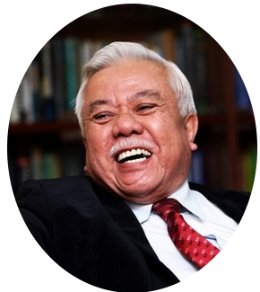

Assalamualaikum and peace be upon you.

DinarPal is company where every solution and service is based on innovation and Islamic point of view. Our wide range of services that we provide speak volumes about the skills we possess. DinarPal Technology consultants and resources possess strong industry knowledge and domain expertise. With a strong focus on reviving the Islamic Financial System and development market, DinarPal intends to use its skills and bring a brand new approach to the industry.

We view clients as partners, and our success is only measured by the success of our partners. So we put it all on the table in order to exceed expectations. We know each new project is a risky, but there is no one we’d rather bet on than ourselves. At DinarPal, our culture matters. And it reflects in our work. Here, jobs are careers, not just a way to pay the bills. The finished product matters to us because it carries our name.

Our staff is young, energetic and innovative, and we are never afraid to take risks in an effort to help our clients. Every member of our team is passionate about the web as a communications medium as well as a marketplace. For every project, no matter how large or how small, we strive to not only meet your needs, but deliver a showcase in your field.

The most important in DinarPal is we established Business Jihad. The Jihad of Peace and Prosperity through Enterprise

**Tan Sri Muhammad Ali Hashim**

**Chairman**

**CEO MESSAGE**

Assalamualaikum and peace be upon you.

DinarPal employs the best talent in the industry. With the objective to provide innovative Islamic Financial Instruments and development services, we have the right mix of experienced resources as well as fresh minds that bring fresh approach to the table.

At DinarPal, we believe that our resources are the building blocks of our organization and they represent the face of our organization



DinarPal employs the best talent in the industry. With the objective to provide innovative Islamic Integrated Financial Instrument and development services, we have the right mix of experienced resources as well as fresh minds that bring fresh approach to the table. Keeping in mind the various sectors of the industry that we cater to, DinarPal employs highly skilled web designers, software engineers, programmers and business developers.

At DinarPal Technology, we believe that our resources are the building blocks of our organization and they represent the face of our organization. That is primarily the reason we stress upon employing the best minds. Every interaction that the customers have with our skilled resources, they can unique different experience that we bring on-board. All our resources and team members are committed to the overall growth and development and strive towards achieving this goal.

**Rashidi Arash Abdul Rashid**

**Chief Executive Officer**

**BOARD OF DIRECTORS**

**“Revive the Sunnah**

**Establish Muamalah“**



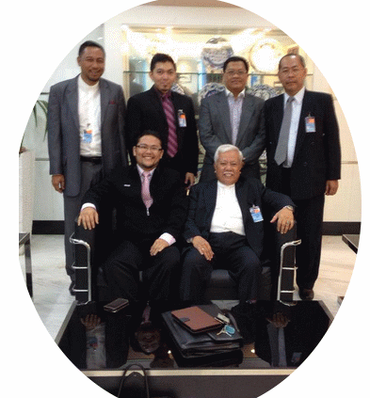

Tn Hj Sahar , Encik Wan Sazli Nasaruddin, Encik Rahman , Encik Sharipuddin

En Rashidi Arash Abdul Rashid, Tan Sri Muhammad Ali Hashim

**COMPANY OUTLINE**

Company Name DinarPal Sdn Bhd

Date Founded May 2013

Capital RM 2,000,000.00

Number of Employees 10

Address Suite 1.2 K-Incubator’

MSC Business City, MITC

75450 Ayer Keroh Melaka

Share Holders Pisang Sdn Bhd – 51%

DPIM Korporat Sdn Bhd – 49%

(To be confirm)

Website https://www.dinarpal.com

**MUSYARAKAH PROPOSAL**

**DINARPAL SDN BHD MUAMALAT SDN BHD**

License outright RM1,800,000.00 Start Up Capital RM2.000,000.00

**DINARPAL SDN BHD MUAMALAT SDN BHD**

CSR 48% CSR 52%

**DINARPAL SDN BHD MUAMALAT SDN BHD**

PSR 48% PSR 52%

**DINARPAL SDN BHD MUAMALAT SDN BHD**

LSR 48% LSR 52%

**FINANCIAL DETAILS**

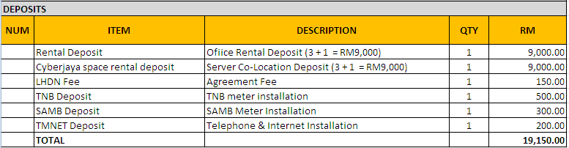

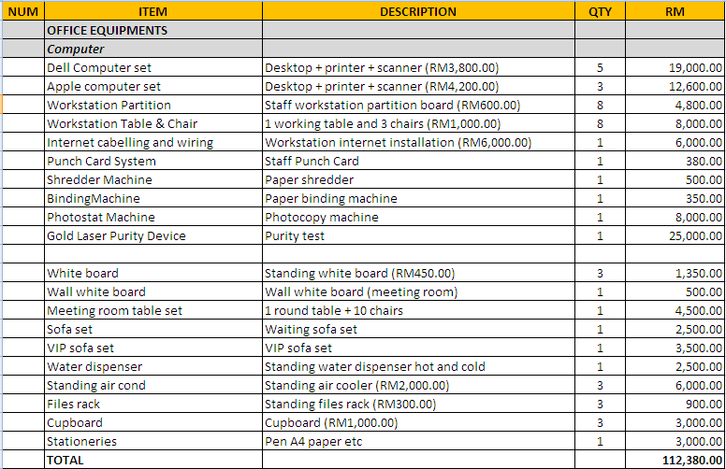

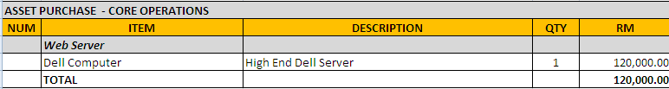

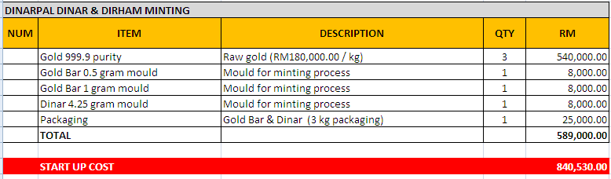

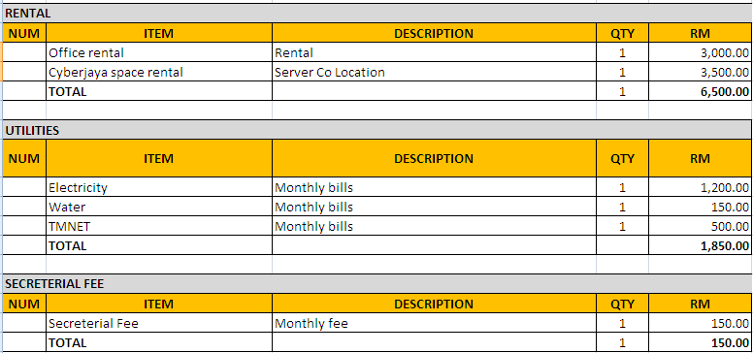

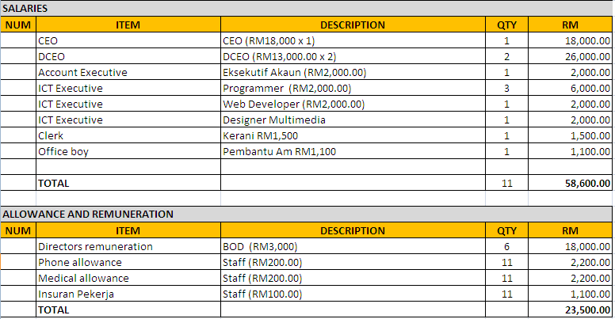

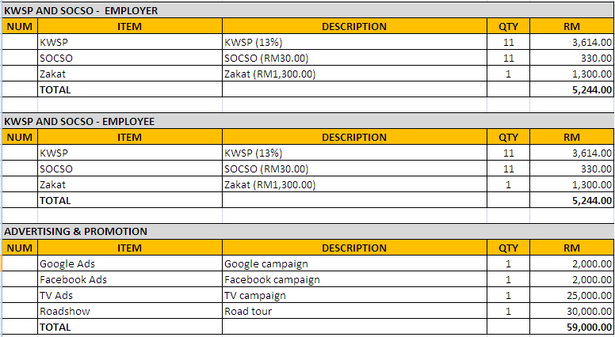

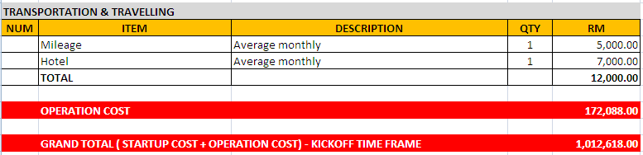

**OPTION**

